Installation and Use of the Europe Online FastSurf Satellite Surfing Software

Installation

After you started the file EOLFastSurfSetup.exe the following window appears. Please click „Next>“ to start the preparation of the installation:
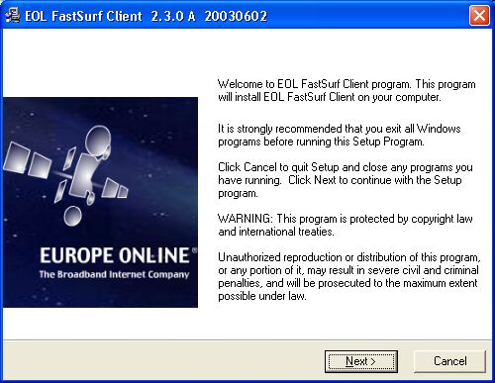

Now please confirm the suggested destination folder by clicking on „Next>“.
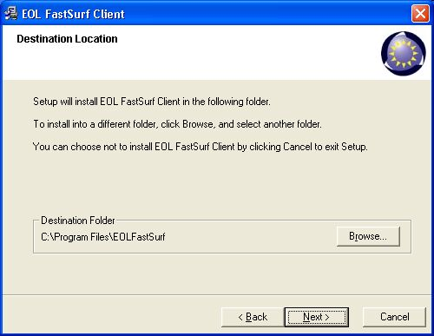

Click „Next“ again to add the FastSurf icons into your start menu.
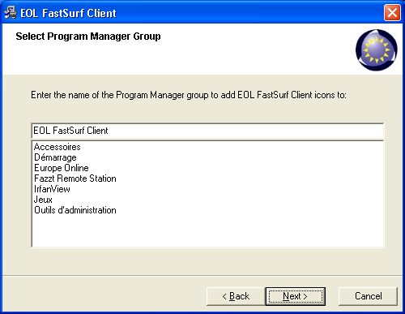

Click „Next>“ to begin with the installation.
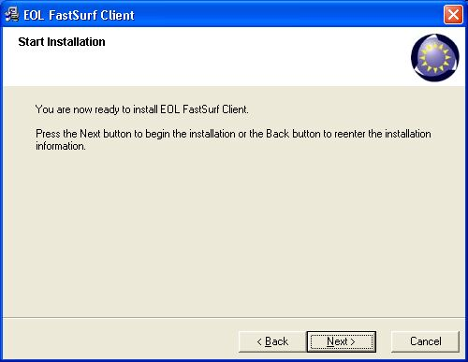

After a few secons all files have been copied. Click „Finish“ to close the installer.
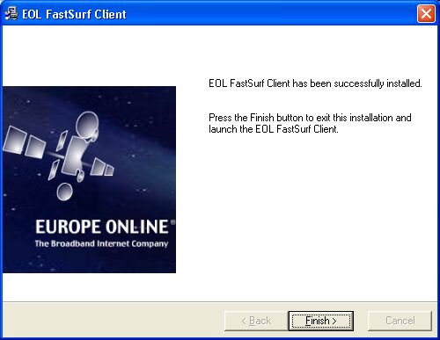

Configuration of your DVB card´s data application for the use with FastSurf

Once the FastSurf software has been installed, please ensure that the filter (PID) 614 hexadecimal is present in the profile of your DVB card data application for the Europe Online transponder 115. In case this filter does not appear there, please add it.

Below are 2 examples of common data profiles (with the concerned filter added):

Technisat Skystar 2 DVB card (DVB or Skysetup/Data Services/ EuropeOnline):
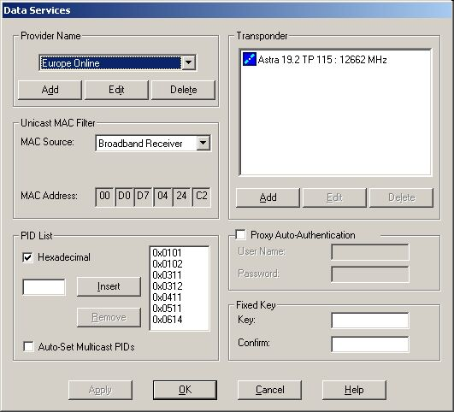

Hauppauge Nova/Technotrend budget:
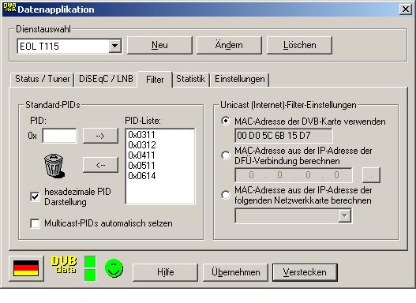
PID 511 can be deleted.
Should your software only accept the adding of decimal PID’s, then please insert PID 1556 instead of 614 hexadecimal.

If you are using the Hauppauge Nexus card and software you need to go to „Filter Options“, choose hexadecimal and then change the Multicast PID to 0x0614 (the others remain on 0x0200). Then click “Apply” and perhaps exit and restart the FastSurf and DVB Data software. The FastSurf icon should turn white then.

Use of the FastSurf software

After the installation of the FastSurf software, you will see a new symbol in the taskbar (in the example below on the far left):

The symbol has to be white (like displayed above) to enable you to use FastSurf.

A yellow or red symbol indicates a configuration error:

in which case one of the following points are the cause:

- did you add the PID 614 hexadecimal (or 1556 decimal) to the profile for transponder 115 in your DVB card´s data application ?

- is the data application of your DVB card started and tuned to transponder 115 ?

- are you using a firewall software? If so, please disable it to see if the colour of FastSurf changes to white after 10-20 seconds. If that is the case then it is proved that your firewall blocks the FastSurf application. Please configure your firewall to trust FastSurf and not block the traffic.

With a white FastSurf icon you can continue to the proxy server configuration which takes place in your browser. FastSurf uses 2 proxy servers (concerning FastSurf these are servers which send the data (websites, etc.) that you request with your modem/ISDN-connection back by satellite).
The servers need to be configured as follows:

Internet Explorer settings:

Please open your Internet Explorer and click on "Tools" and then on „Internet Options".

Now please choose “Connections” and click on the dial-up connection that you intend to use with FastSurf. Then click on “Settings” on the right.

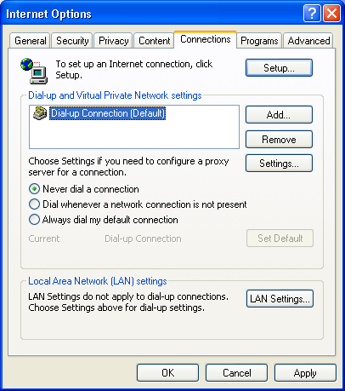

Now a new comes up in which you need to tick „Use a proxy server“ and „Bypass proxy server for local addresses“. Once done click on „Advanced“ on the right.

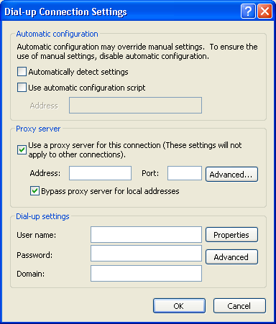

Please enter the http and socks proxy as displayed underneath. Then confirm your entries with a click on „OK“ and ensure that there are no spaces after the word localhost. 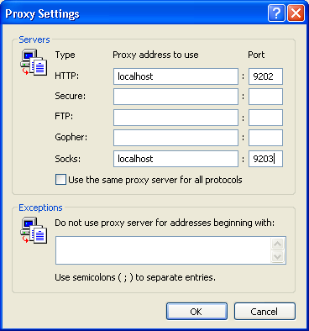

Netscape settings

Please open your Netscape browser, choose the menu item "edit" and then select "Preferences". Now double click "Advanced" in the Category tree and choose "Proxies". Select "Manual Proxy Configuration", and in the HTTP-Proxy line please enter "localhost" with "9202" as the port. In the Socks line enter "localhost" with "9203" as port. Finally click "OK".

Login

To log in to FastSurf, please start your internet connection (the one for which you just now configured the proxy servers in the browser).

Once this connection is established, do a right click on the white EOL icon in the taskbar and choose „Login“.

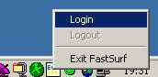

On the login page, please enter your username and password and click „Login“: 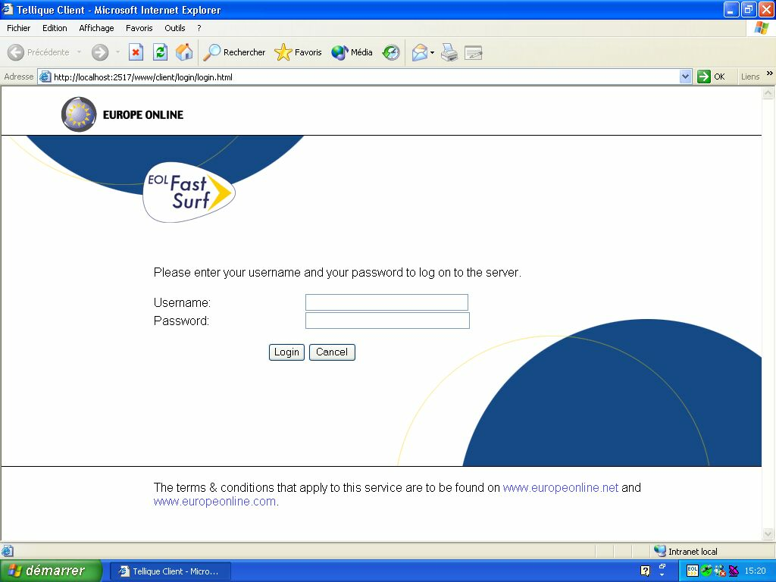

You will then receive the message „Your login was successful“:
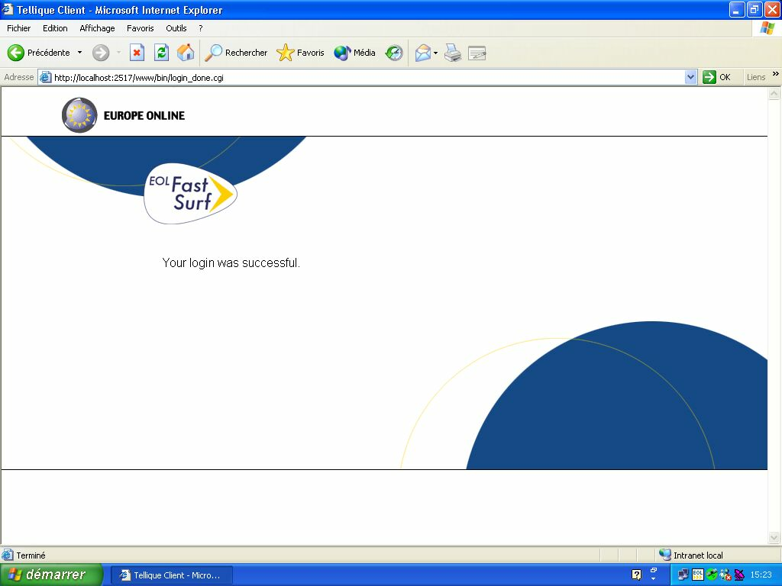

and can start surfing using the satellite speed of FastSurf.

To surf without FastSurf you need to untick the proxy server setting in your browser.

However, please use the „Logout“ function to end your session correctly:
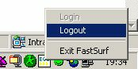

The time and volume you used FastSurf for can be checked at https://secure.europeonline.com/FastSurf/Volume.php
Simply use your username and password to log in.


Further useful information and FAQ’s about FastSurf can be found on www.europeonline.net by clicking on “HELP/FAQ” in the upper navigation bar and then choosing FastSurf in the menu on the left.

